# Topic: Survival Analytics

**Instructions:**

Please share your answers filled in-line in the word document. Submit code separately wherever applicable.

Please ensure you update all the details:

**Name: Chinni ganesh**

**Batch Id: 23-09-21**

**Topic: Survival Analytics**

**Grading Guidelines:**

**1. An assignment submission is considered complete only when correct and executable code(s) are submitted along with the documentation explaining the method and results. Failing to submit either of those will be considered an invalid submission and will not be considered for evaluation.**

**2. Assignments submitted after the deadline will affect your grades.**

**Grading:**

|  |  |  |  |  |  |
| --- | --- | --- | --- | --- | --- |
| **Ans** | **Date** |  |  | **Ans** | **Date** |
| Correct | On time | A | 100 |  |  |
| 80% & above | On time | B | 85 | Correct | Late |
| 50% & above | On time | C | 75 | 80% & above | Late |
| 50% & below | On time | D | 65 | 50% & above | Late |
|  |  | E | 55 | 50% & below |  |
| Copied/No Submission |  | F | 45 |  |  |

* **Grade A: (>= 90):** When all assignments are submitted on or before the given deadline.
* **Grade B: (>= 80 and < 90):** 
  + When assignments are submitted on time but less than 80% of problems are completed.

(OR)

* + All assignments are submitted after the deadline.
* **Grade C: (>= 70 and < 80):** 
  + When assignments are submitted on time but less than 50% of the problems are completed.

(OR)

* + Less than 80% of problems in the assignments are submitted after the deadline.
* **Grade D: (>= 60 and < 70):**
  + Assignments submitted after the deadline and with 50% or less problems.
* **Grade E: (>= 50 and < 60):** 
  + Less than 30% of problems in the assignments are submitted after the deadline.

(OR)

* + Less than 30% of problems in the assignments are submitted before the deadline.
* **Grade F: (< 50):** No submission (or) malpractice.

**Hints:**

1. **Business Problem**
   1. **What is the business objective?**
   2. **Are there any constraints?**
2. **Work on each feature of the dataset to create a data dictionary as displayed in the below image:**

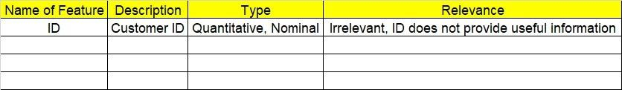

**2.1 Make a table as shown above and provide information about the features such as its Data type and its relevance to the model building, if not relevant provide reasons and provide description of the feature.**

1. **Exploratory Data Analysis (EDA):**
   1. **Summary.**
   2. **Univariate analysis.**
   3. **Bivariate analysis.**
2. **Model Building**

**4.1 Build the model on the scaled data (try multiple options).**

**4.2 Perform survival analytics on the given datasets.**

**4.3 Briefly explain the model output in the documentation.**

1. **Write about the benefits/impact of the solution - in what way does the business (client) benefit from the solution provided?**

**Problem Statement:**

The following dataset contains patient ID, follow up, event type, and scenarios. Build a survival analysis model on the given data.

**Business problem**: the following dataset contains PatientID ,Follow up ,Event type &

Scenarios. survival analysis model has to be built on the Follow up

Sol:

**Business Objective:** To apply survival analysis on the patients data set to perform follow up times for patients.

**Survival analysis:** survival analysis is made for the given data set by taking the time variables as follow-up and event variable as event type.

Keplan-Meier Survival Plot for the given data set by taking the event type as 1 and out put as patient as follows.

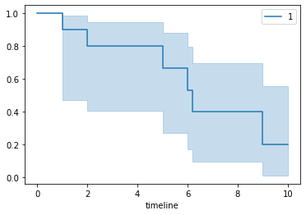 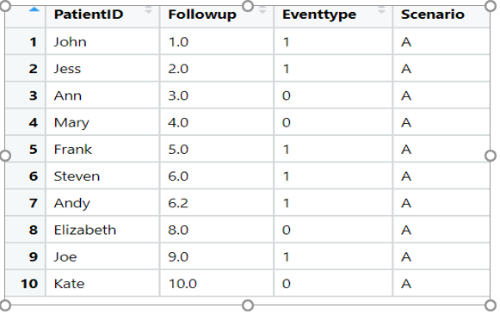

**Problem Statement: -**

ECG of different age groups of people has been recorded. The survival time in hours after the operation is given and the event type is denoted by 1 (if dead) and 0 (if alive). Perform survival analysis on the dataset given below and provide your insights in the documentation.

Sol:

**Business Objective:** To apply survival analysis on the people ECG data set to perform follow up alive for patients.

**Survival analysis:** survival analysis is made for the given data set by taking the time variables as survival_time_hr and event variable as alive.

Keplan-Meier Survival Plot for the given data set by taking the group type as 1,2,3 and out put as patient as follows.



